# VISVESVARAYA TECHNOLOGICAL UNIVERSITY

## BELAGAVI – 590018, Karnataka INTERNSHIP REPORT

#### ON

“Machine Learning algorithms for predicting the risks of chronic diseases”

***Submitted in partial fulfillment for the award of degree(18CSI85)***

## BACHELOR OF ENGINEERING IN

## Electronics And Communication

***Submitted by:***

#### Bhargavi M

#### 2BL20EC022



Conducted at

**Varcons Technologies Pvt Ltd**



***BLDEA’s Engineering College of Technology Vijayapura***

Electronics and Communication

Accredited by NBA, New Delhi

Ashram Road, Vijayapura-586101

**CERTIFICATE**

This is to certify that the Internship titled **“Machine Learning algorithms for predicting the risks of chronic diseases””** carried out by **Miss. Bhargavi M,** a bonafide student of BLDEA’s Institute of Technology, in partial fulfillment for the award of **Bachelor of Engineering**, in Electronics and Communication under Visvesvaraya Technological University, Belagavi, during the year 2022-2023. It is certified that all corrections/suggestions indicated have been incorporated in the report.

The project report has been approved as it satisfies the academic requirements in respect of Internship prescribed for the course Internship / Professional Practice (18CSI85)

#### Signature of Guide Signature of HOD Signature of Principal

**External Viva:**

Name of the Examiner Signature with Date

1)

2)

# D E C L A R A T I O N

I, **Bhargavi M**, final year student of Branch, College Name - 560 082, declare that the Internship has been successfully completed, in. Varcons Technologies Pvt Ltd This report is submitted in partial fulfillment of the requirements for award of a Bachelor's Degree in Electronics and Communication, during the academic year 2022-2023.

Date :21-09-2023 :

Place : Vijayapura

USN : 2BL20EC022

NAME : Bhargavi Mokashi

**OFFER LETTER**



# A C K N O W L E D G E M E N T

This Internship is a result of accumulated guidance, direction and support of several important persons. We take this opportunity to express our gratitude to all who have helped us to complete the Internship.

We express our sincere thanks to our Principal, for providing us adequate facilities to undertake this Internship.

We would like to thank our Head of Dept – branch code, for providing us an opportunity to carry out Internship and for his valuable guidance and support.

We would like to thank our (Lab assistant name) Software Services for guiding us during the period of internship.

We express our deep and profound gratitude to our guide, Guide name, Assistant/Associate Prof, for her keen interest and encouragement at every step in completing the Internship.

We would like to thank all the faculty members of our department for the support extended during the course of Internship.

We would like to thank the non-teaching members of our dept, forhelping us during the Internship.

Last but not the least, we would like to thank our parents and friends without whose constant help, the completion of Internship would have not been possible.

**NAME: Bhargavi M**

**USN: 2BL20EC022**

# ABSTRACT

Technological development, including machine learning, has a huge impact on health through an effective analysis of various chronic diseases for more accurate diagnosis and successful treatment. In the field of biomedical and healthcare communities, accurate prediction plays a major role in finding out the risk of the disease in the patient. The only way to overcome mortality due to chronic diseases is to predict it earlier so that disease prevention can be done. Such a model is a Patient’s need in which Machine Learning is highly recommendable. However, the precise prediction on the basis of symptoms becomes too difficult for doctors. The correct prediction of disease is the most stretching task. To overcome this problem data mining plays an important role in predicting the disease. This study analyzes chronic diseases using machine-learning techniques based on a chronic disease dataset from the UCI machine-learning data warehouse. We use Heart disease, Kidney disease, Cancer disease, and Diabetes disease datasets, In order to build reliable prediction models for these chronic diseases using data mining techniques. The most relevant features are selected from the dataset for improved accuracy and reduced training time. The system analyzes the symptoms provided by the user as input and gives the probability of the disease as an output Disease Prediction is done by implementing the Logistic Regression. By using logistic regression, random forest, and decision tree we are predicting diseases like Diabetes, Heart, Cancer, and Kidney. For each chronic disease, diverse models, techniques, and algorithms are used for predicting and analyzing. The paper comprises a conceptual model that integrates the prediction of the most common chronic diseases. Keywords: Logistic Regression, Chronic Diseases, Machine Learning, Diseases Prediction and Accuracy

# Table of Contents

|  |  |  |
| --- | --- | --- |
| **Sl no** | **Description** | **Page no** |
| 1 | Company Profile | 8 |
| 2 | About the Company | 12 |
| [3](https://1.bp.blogspot.com/-dODuK8N5h1Q/Wlnyb3V9HFI/AAAAAAAACL4/WxQtCJ1pM5wccDABg4wIrTBUB0vlikXQQCLcBGAs/s1600/poly1.jpg) | Introduction | 16 |
| [4](https://1.bp.blogspot.com/-dODuK8N5h1Q/Wlnyb3V9HFI/AAAAAAAACL4/WxQtCJ1pM5wccDABg4wIrTBUB0vlikXQQCLcBGAs/s1600/poly1.jpg) | System Analysis | 21 |
| [5](https://1.bp.blogspot.com/-dODuK8N5h1Q/Wlnyb3V9HFI/AAAAAAAACL4/WxQtCJ1pM5wccDABg4wIrTBUB0vlikXQQCLcBGAs/s1600/poly1.jpg) | Requirement Analysis | 25 |
| 6 | Design [Analysis](https://4.bp.blogspot.com/-IOOxgPaXMVc/Wlj3LWvcnjI/AAAAAAAACKE/UeTFYvAxDmUDel5UBjdifeWaApB3-dXVgCLcBGAs/s1600/img1.jpg) | 28 |
| 7 | [Implementation](https://4.bp.blogspot.com/-IOOxgPaXMVc/Wlj3LWvcnjI/AAAAAAAACKE/UeTFYvAxDmUDel5UBjdifeWaApB3-dXVgCLcBGAs/s1600/img1.jpg) | 29 |
| 8 | Snapshots | 32 |
| 9 | Conclusion | 34 |
| 10 | References |  |

[**CHAPTER**](https://1.bp.blogspot.com/-dODuK8N5h1Q/Wlnyb3V9HFI/AAAAAAAACL4/WxQtCJ1pM5wccDABg4wIrTBUB0vlikXQQCLcBGAs/s1600/poly1.jpg) **1** **COMPANY PROFILE**

# COMPANY PROFILE

## A Brief History of Company

Company, was incorporated with a goal ”To provide high quality and optimal Technological Solutions to business requirements of our clients”. Every business is a different and has a unique business model and so are the technological requirements. They understand this and hence the solutions provided to these requirements are different as well. They focus on clients requirements and provide them with tailor made technological solutions. They also understand that Reach of their Product to its targeted market or the automation of the existing process into e-client and simple process are the key features that our clients desire from Technological Solution they are looking for and these are the features that we focus on while designing the solutions for their clients.

Company is a Technology Organization providing solutions for all web design and development, MYSQL, PYTHON Programming, HTML, CSS, ASP.NET and LINQ. Meeting the ever increasing automation requirements, Sarvamoola Software Services. specialize in ERP, Connectivity, SEO Services, Conference Management, effective web promotion and tailor-made software products, designing solutions best suiting clients requirements.

we strive to be the front runner in creativity and innovation in software development through their well-researched expertise and establish it as an out of the box software development company in Bangalore, India. As a software development company, they translate this software development expertise into value for their customers through their professional solutions.

They understand that the best desired output can be achieved only by understanding the clients demand better. At our Company we work with them clients and help them to defiine their exact solution requirement. Sometimes even they wonder that they have completely redefined their solution or new application requirement during the brainstorming session, and here they position themselves as an IT solutions consulting group comprising of high caliber consultants.

They believe that Technology when used properly can help any business to scale and achieve new heights of success. It helps Improve its efficiency, profitability, reliability; to put it in one sentence ” Technology helps you to Delight your Customers” and that is what we want to achieve.

# [CHAPTER](https://1.bp.blogspot.com/-dODuK8N5h1Q/Wlnyb3V9HFI/AAAAAAAACL4/WxQtCJ1pM5wccDABg4wIrTBUB0vlikXQQCLcBGAs/s1600/poly1.jpg) 2 ABOUT THE COMPANY

We are a Technology Organization providing solutions for all web design and development, Researching and Publishing Papers to ensure the quality of most used ML Models, MYSQL, PYTHON Programming, HTML, CSS, ASP.NET and LINQ. Meeting the ever increasing automation requirements, Compsoft Technologies specialize in ERP, Connectivity, SEO Services, Conference Management, effective web promotion and tailor-made software products, designing solutions best suiting clients requirements. The organization where they have a right mix of professionals as a stakeholders to help us serve our clients with best of our capability and with at par industry standards. They have young, enthusiastic, passionate and creative Professionals to develop technological innovations in the field of Mobile technologies, Web applications as well as Business and Enterprise solution. Motto of our organization is to “Collaborate with our clients to provide them with best Technological solution hence creating Good Present and Better Future for our client which will bring a cascading a positive effect in their business shape as well”. Providing a Complete suite of technical solutions is not just our tag line, it is Our Vision for Our Clients and for Us, We strive hard to achieve it.

Varcons Technologies is a Technology Organization providing solutions for all web design

and development, MYSQL, PYTHON Programming, HTML, CSS, ASP.NET and LINQ.

Meeting the ever increasing automation requirements, Varcons Technologies specializes in

ERP, Connectivity, SEO Services, Conference Management, effective web promotion, and

tailor-made software products, designing solutions best-suiting clients' requirements. The

organization where they have the right mix of professionals as stakeholders to help us serve

our clients to the best of our capability and with at-par industry standards. They have young,

enthusiastic, passionate, and creative Professionals to develop technological innovations in the

field of Mobile technologies, Web applications as well as Business and Enterprise solutions.

The motto of our organization is to “Collaborate with our clients to provide them with the best

Technological solution hence creating Good Present and Better Future for our client which

will bring a cascading a positive effect in their business shape as well”. Providing a Complete

suite of technical solutions is not just our tag line, it is Our Vision for Our Clients and for Us,

We strive hard to achieve it.

**Android Apps**

It is the process by which new applications are created for devices running the Android

operating system. Applications are usually developed in Java (and/or Kotlin; or other such

option) programming language using the Android software development kit (SDK), but other

development environments are also available, some such as Kotlin support the exact same

Android APIs (and bytecode), while others such as Go have restricted API access.

The Android software development kit includes a comprehensive set of development tools.

These include a debugger, libraries, a handset emulator based on QEMU, documentation,

sample code, and zutorials. Currently supported development platforms include computers

running Linux (any modern desktop Linux distribution), Mac OS X 10.5.8 or later, and

Windows 7 or later. As of March 2015, the SDK is not available on Android itself, but

software development is possible by using specialized Android applications.

**Web Application**

It is a client–server computer program in which the client (including the user interface and

client- side logic) runs in a web browser. Common web applications include webmail, online

retail sales, online auctions, wikis, instant messaging services, and many other functions. web

applications use web documents written in a standard format such as HTML and

JavaScript, which is supported by a variety of web browsers. Web applications can

be considered as a specific variant of client–server software where the client software is

downloaded to the client machine when visiting the relevant web page, using standard

procedures such as HTTP. The Client web software updates may happen each time the web

page is visited. During the session, the web browser interprets and displays the pages,

and acts as the universal client for any web application. The use of web application

frameworks can often reduce the number of errors in a program, both by making the code

simpler, and by allowing one team to concentrate on the framework while another focuses

on a specified use case. In applications that are exposed to constant hacking attempts on

the Internet, security-related problems can be caused by errors in the program.

Frameworks can also promote the use of best practices such as GET after POST. There

are some who view a web application as a two-tier architecture. This can be a “smart” client

that performs all the work and queries a “dumb” server, or a “dumb” client that relies on a

“smart” server. The client would handle the presentation tier, the server would have the

database (storage tier), and the business logic (application tier) would be on one of them

or on both. While this increases the scalability of the applications and separates the

display and the database, it still does not allow for true specialization of layers, so most

applications will outgrow this model. An emerging strategy for application software

companies is to provide web access to software previously distributed as local applications.

Depending on the type of application, it may require the development of an entirely different

browser-based interface, or merely adapting an existing application to use different

presentation technology. These programs allow the user to pay a monthly or yearly fee

for the use of a software application without having to install it on a local hard drive. A

company that follows this strategy is known as an application service provider (ASP),

and ASPs are currently receiving much attention in the software industry.

Security breaches on these kinds of applications are a major concern because it can involve

both enterprise information and private customer data. Protecting these assets is an important

part of any web application and there are some key operational areas that must be included

in the development process. This includes processes for authentication, authorization, asset

handling, input, and logging and auditing. Building security into the applications from the

beginning can be more effective and less disruptive in the long run.

Web design

It encompasses many different skills and disciplines in the production and maintenance of

websites. The different areas of web design include web graphic design; interface design;

authoring, including standardized code and proprietary software; user experience design;

and

search engine optimization. The term web design is normally used to describe the design

process relating to the front-end (client side) design of a website including writing markup.

Web design partially overlaps web engineering in the broader scope of web development.

Web designers are expected to have an awareness of usability and if their role involves

creating markup up then they are also expected to be up to date with web accessibility

guidelines. Web design partially overlaps web engineering in the broader scope of web development

**Departments and services offered**

Varcons Technologies plays an essential role as an institute, the level of education,

and development of student’s skills are based on their trainers. If you do not have a good mentor

then you may lag in many things from others and that is why we at Varcons Technologies

gives you the facility of skilled employees so that you do not feel unsecured about the

academics. Personality development and academic status are some of those things which lie

on mentor’s hands. If you are trained well then you can do well in your future and knowing

its importance of Varcons Technologies always tries to give you the best.

They have a great team of skilled mentors who are always ready to direct their trainees in the

the best possible way they can and to ensure the skills of mentors we held much skill

development programs as well so that each and every mentor can develop their own skills

with the demands of the companies so that they can prepare a completely packaged trainee.

## Services provided by Compsoft Technologies.

* Core Java and Advanced Java
* Research and Development/Improvise of ML Models
* Web services and development
* Dot Net Framework
* Python
* Selenium Testing
* Conference / Event Management Service
* Academic Project Guidance
* On The Job Training
* Software Training

# [CHAPTER](https://1.bp.blogspot.com/-dODuK8N5h1Q/Wlnyb3V9HFI/AAAAAAAACL4/WxQtCJ1pM5wccDABg4wIrTBUB0vlikXQQCLcBGAs/s1600/poly1.jpg) 3

# INTRODUCTION

Introduction to ML

Machine learning is programming computers to optimize a performance using example data or past data. Machine learning is study of computer systems that learn from data and experience. ML is categorized as supervised (i.e., consists of output variables that are predicted from input variables) or unsupervised (i.e., deals with clustering of different groups for a particular intercession). ML is used to determine complex models, and extract medical knowledge, exposing novel ideas to professionals, and specialists. In clinical practice, ML predictive models can highlight strengthened rules in the decision-making regarding individual patient care. These are also capable of autonomous diagnosis of different diseases under clinical rules. The incorporation of these models in drug prescription can save doctors and offer new medical opportunities in identification. Machine learning has been shown to be effective in supporting making decisions and predictions from the large quantity of data produced by the healthcare industry. We streamline machine learning algorithms for effective prediction of chronic disease breakout. Various studies give only a glimpse into predicting disease with ML techniques. We propose a novel method that aims at finding significant features by applying machine learning techniques such as the K-Nearest Neighbor Algorithm (KNN), Decision Trees (DT), Logistic Regression, Random Forest, and Naive Bayes (NB) resulting in improving the accuracy in the prediction of disease. Multiple such algorithms are carried out to improve the accuracy of the learning process. It can then be tested with the available datasets. The prediction model is introduced with different combinations of features and various known classification techniques. With ML models, it can also be possible to improve the quality of medical data, reduce variation in patient rates, and save on medical costs. Therefore, these models are frequently used to investigate diagnostic analysis when compared with other conventional methods. To reduce the death rates caused by chronic diseases (CDs), early detection and effective therapy are the only solutions. Therefore, most medical scientists are attracted to the new technologies of predictive models in disease estimation. These new advancements in medical care have been spreading the accessibility of electronic data and opening new doors for decision support and productivity improvements. ML methods have been effectively utilized in the computerized elucidation of pneumonic capacity tests for the differential analysis of CDs. It is expected that the models with the highest accuracies could gain large importance in medical diagnosis

Machine learning is programming computers to optimize performance using example data or past data. Machine learning is the study of computer systems that learn from data and experience. ML is categorized as supervised (i.e., consists of output variables that are predicted from input variables) or unsupervised (i.e., deals with clustering of different groups for a particular intercession). ML is used to determine complex models and extract medical knowledge, exposing novel ideas to professionals, and specialists. In clinical practice, ML predictive models can highlight strengthened rules in the decision-making regarding individual patient care. These are also capable of autonomous diagnosis of different diseases under clinical rules. The incorporation of these models in drug prescription can save doctors and offer new medical opportunities in identification. Machine learning has been shown to be effective in supporting making decisions and predictions from the large quantity of data produced by the healthcare industry. We streamline machine learning algorithms for effective prediction of chronic disease breakout. Various studies give only a glimpse into predicting disease with ML techniques. We propose a novel method that aims at finding significant features by applying machine learning techniques such as the K-Nearest Neighbor Algorithm (KNN), Decision Trees (DT), Logistic Regression, Random Forest, and Naive Bayes (NB) resulting in improving the accuracy in the prediction of disease. Multiple such algorithms are carried out to improve the accuracy of the learning process. It can then be tested with the available datasets. The prediction model is introduced with different combinations of features and various known classification techniques. With ML models, it can also be possible to improve quality of medical data, reduce variation in patient rates, and save in medical costs. Therefore, these models are frequently used to investigate diagnostic analysis when compared with other conventional methods. To reduce the death rates caused by chronic diseases (CDs), early detection and effective therapy are the only solutions. Therefore, most medical scientists are attracted to the new technologies of predictive models in disease estimation. These new advancements in medical care have been spreading the accessibility of electronic data and opening new doors for decision support and productivity improvements. ML methods have been effectively utilized in the computerized elucidation of pneumonic capacity tests for the differential analysis of CDs. It is expected that the models with the highest accuracies could gain large importance in medical diagnosis.

## Problem Statement

## The problem at hand is the rising prevalence of chronic diseases worldwide, which places an enormous burden on healthcare systems and negatively impacts individuals' quality of life. Despite advancements in healthcare, early prediction and prevention of chronic diseases remain a challenge. The absence of an efficient, data-driven system for assessing an individual's risk of developing chronic diseases hinders proactive intervention and tailored healthcare strategies.

## Background

Chronic diseases, such as heart disease, diabetes, cancer, and respiratory illnesses, are the leading causes of morbidity and mortality worldwide. These diseases impose a substantial economic and healthcare burden on societies, affecting individuals, families, and healthcare systems. The significance of chronic diseases lies not only in their prevalence but also in their often preventable nature. Early identification of individuals at risk is a critical step towards reducing the incidence and severity of chronic diseases.

**Problem Overview**

Despite significant advances in healthcare, the prediction of chronic disease risks remains a complex and challenging task. Traditional risk assessment methods often rely on static demographic factors and historical health records, overlooking dynamic and personalized aspects of an individual's health. To address this limitation, there is a pressing need for a data-driven and machine learning-based solution that can:

1. **Accurately Predict Disease Risks:** Develop predictive models capable of assessing an individual's risk of developing specific chronic diseases based on a diverse set of health-related features. These features may include genetic information, lifestyle factors, environmental exposures, and medical history.
2. **Facilitate Early Intervention:** Enable early identification of high-risk individuals, allowing for timely intervention and personalized healthcare recommendations. Early detection can lead to improved disease management and, in some cases, prevention.
3. **Improve Healthcare Decision-Making:** Provide healthcare professionals and individuals with actionable insights and recommendations based on risk assessments. This empowers individuals to make informed decisions about their health and enables healthcare providers to tailor interventions to the individual's unique risk profile.

**Scope of the Project**

This project aims to design, develop, and deploy a comprehensive machine learning system for predicting the risks of specific chronic diseases. The system will involve the following key components and functionalities:

1. **Data Collection:** Gather a diverse dataset comprising individual health-related data, including medical history, genetic information, lifestyle factors, and environmental exposures.
2. **Data Preprocessing:** Clean, preprocess, and transform the collected data to ensure data quality and consistency. Handle missing values, outliers, and ensure proper encoding of categorical variables.
3. **Feature Engineering:** Employ feature selection and engineering techniques to identify the most relevant features for disease risk prediction.
4. **Machine Learning Model Development:** Select and implement state-of-the-art machine learning algorithms, such as ensemble methods, deep learning models, or hybrid approaches, to build robust predictive models for chronic disease risks.
5. **User Interface:** Develop a user-friendly interface that allows healthcare professionals and individuals to input their data, access risk assessments, and receive personalized recommendations.
6. **Model Evaluation:** Implement comprehensive evaluation metrics to assess the performance and reliability of the predictive models. Metrics may include accuracy, precision, recall, F1-score, and area under the receiver operating characteristic curve (AUC-ROC).
7. **Deployment:** Deploy the developed system in a secure and scalable environment, making it accessible to healthcare providers and individuals seeking risk assessments.

**Significance**

This project addresses a critical gap in healthcare by harnessing the power of machine learning to predict chronic disease risks accurately. By empowering individuals and healthcare professionals with timely and personalized risk assessments, we can potentially reduce the burden of chronic diseases, improve healthcare decision-making, and enhance the overall well-being of individuals and communities.

# [CHAPTER](https://1.bp.blogspot.com/-dODuK8N5h1Q/Wlnyb3V9HFI/AAAAAAAACL4/WxQtCJ1pM5wccDABg4wIrTBUB0vlikXQQCLcBGAs/s1600/poly1.jpg) 4

# SYSTEM ANALYSIS

## 1.Existing System:

## Demographic and Historical Data: The existing system primarily utilizes demographic information such as age, gender, and family medical history, along with historical health records, to assess an individual's risk of chronic diseases. These records include past diagnoses, medical procedures, and medication history.

## Risk Assessment Tools: Healthcare professionals often use established risk assessment tools and scoring systems (e.g., Framingham Risk Score for cardiovascular diseases) to estimate disease risk. These tools are based on statistical models that consider a limited set of risk factors.

## Limited Personalization: The existing system lacks personalization and often treats individuals as part of a broader population rather than considering their unique genetic, lifestyle, and environmental factors. This one-size-fits-all approach may lead to inaccurate risk assessments.

## Manual Data Entry: Patients typically provide their health information during medical visits, which is then manually recorded by healthcare providers. This process can be time-consuming, error-prone, and may not capture a comprehensive health history.

## Late Intervention: Due to the limitations of the existing system, interventions often occur when chronic diseases have already advanced, leading to more extensive treatment and reduced effectiveness in prevention.

## Lack of Data Integration: Healthcare data is often fragmented across various healthcare providers, making it challenging to obtain a holistic view of an individual's health. Data sharing and integration are limited.

## Data Privacy Concerns: Patient health data is sensitive, and ensuring privacy and compliance with data protection regulations is a significant challenge in the existing system.

## Limited Use of Advanced Technologies: Advanced technologies like machine learning, genetic sequencing, and wearable health devices are not fully integrated into the existing system.

## Conclusion

## In conclusion, The development of a machine learning-based system for predicting chronic disease risks represents a pivotal step in the ongoing battle against the global epidemic of chronic diseases. By leveraging data and advanced analytics, this project endeavors to contribute to more proactive and personalized healthcare, ultimately leading to better health outcomes and a higher quality of life

2.Proposed System:

The proposed system for predicting chronic disease risks aims to overcome the limitations of the existing system by leveraging advanced data analytics, machine learning, and personalized medicine. Here's an overview of the key features and components of the proposed system:

1. Comprehensive Data Integration: The proposed system will integrate data from diverse sources, including electronic health records (EHRs), genetic sequencing, wearable health devices, lifestyle questionnaires, and environmental data. This comprehensive data integration provides a holistic view of an individual's health.
2. Data Preprocessing and Quality Assurance: Robust data preprocessing techniques will be employed to clean, normalize, and validate the integrated data. This ensures data quality and consistency, reducing the risk of inaccurate predictions.
3. Advanced Feature Engineering: Feature engineering will involve identifying and selecting the most relevant features for disease risk prediction. Techniques such as feature selection, dimensionality reduction, and feature engineering algorithms will be applied.
4. Machine Learning Models: State-of-the-art machine learning algorithms, including but not limited to random forests, support vector machines, deep neural networks, and ensemble methods, will be utilized to build predictive models. These models will take into account the diverse set of features to accurately estimate disease risks.
5. Personalized Risk Assessment: The proposed system will provide personalized risk assessments for each individual. It will consider an individual's genetic predisposition, lifestyle choices, environmental exposures, and health history to tailor risk predictions.
6. Real-time Monitoring: Integration with wearable health devices will enable real-time monitoring of vital health parameters. This data will be continuously fed into the system to update risk assessments dynamically.
7. User-Friendly Interface: A user-friendly interface will be developed for both healthcare professionals and individuals. Users can input their data, access risk assessments, and receive personalized recommendations for disease prevention and management.
8. Privacy and Security: Stringent data privacy and security measures will be implemented to protect sensitive health information. The system will adhere to data protection regulations and best practices for securing healthcare data.
9. Scalability: The proposed system will be designed with scalability in mind to handle large volumes of data and accommodate future growth in data sources and users.
10. Evaluation and Validation: Comprehensive evaluation metrics will be used to assess the performance and reliability of the predictive models. Continuous validation and feedback mechanisms will ensure model accuracy and effectiveness.
11. Interoperability: Efforts will be made to enhance data interoperability, allowing seamless data sharing and integration across healthcare providers and systems.

Early Intervention and Prevention: By providing early, accurate, and personalized risk assessments, the proposed system aims to enable timely interventions and preventive measures, ultimately reducing the incidence and severity of chronic diseases.

**3. Objective of the System:**

## The primary objective of the proposed system for predicting chronic disease risks is to leverage advanced data analytics and machine learning techniques to provide accurate, personalized, and early risk assessments for chronic diseases. The system aims to address several specific objectives:

## Accurate Risk Prediction: Develop machine learning models capable of accurately assessing an individual's risk of developing specific chronic diseases. These predictions should be based on a diverse set of health-related data sources, including genetic, lifestyle, environmental, and medical history data.

## Personalization: Tailor risk assessments to the unique characteristics and circumstances of each individual. Recognize that disease risks vary significantly among individuals, and the system should provide personalized insights and recommendations.

## Early Intervention: Enable early identification of individuals at high risk of chronic diseases, allowing for timely interventions. Early interventions can include lifestyle modifications, preventative measures, and personalized healthcare plans.

## Data Integration: Integrate data from various sources, such as electronic health records, genetic sequencing, wearable devices, and surveys, to provide a comprehensive view of an individual's health. Overcome data fragmentation and enable holistic risk assessment.

## User-Friendly Interface: Develop an intuitive user interface that allows both healthcare professionals and individuals to interact with the system easily. Users should be able to input their data, access risk assessments, and receive clear and actionable recommendations.

## Real-time Monitoring: Incorporate real-time health monitoring through wearable devices to continuously update risk assessments. Provide individuals and healthcare providers with insights into changing health conditions.

## Privacy and Security: Implement robust data privacy and security measures to protect sensitive health information. Comply with data protection regulations and ensure secure data handling and storage.

## Scalability: Design the system to handle large volumes of data and accommodate future growth in data sources and users. Ensure scalability without compromising performance.

## Evaluation and Validation: Continuously evaluate and validate the predictive models to ensure their accuracy and reliability. Incorporate feedback mechanisms to improve model performance over time.

## Interoperability: Enhance data interoperability to facilitate seamless data sharing and integration with other healthcare systems and providers. Promote collaboration and data exchange for improved patient care.

## Empower Healthcare Decision-Making: Empower healthcare professionals with accurate risk assessments to make informed decisions about patient care and interventions. Enable individuals to take an active role in managing their health.

Reduce Disease Burden: Ultimately, the overarching objective is to reduce the burden of chronic diseases on individuals and society as a whole. By providing early, accurate risk assessments and facilitating preventive measures, the system aims to lower the incidence and severity of diseases

# [CHAPTER](https://1.bp.blogspot.com/-dODuK8N5h1Q/Wlnyb3V9HFI/AAAAAAAACL4/WxQtCJ1pM5wccDABg4wIrTBUB0vlikXQQCLcBGAs/s1600/poly1.jpg) 5 REQUIREMENT ANALYSIS

## Hardware Requirement Specification:

## The hardware specifications for a project involving machine learning for predicting chronic disease risks can vary depending on the scale of the project, the complexity of machine learning models, and the size of the dataset. Here are hardware specifications for a mid-range project:

## CPU (Central Processing Unit):

## A modern multi-core processor (e.g., Intel Core i7 or AMD Ryzen 7) for handling data preprocessing, model training, and inference efficiently.

## GPU (Graphics Processing Unit) (Optional but recommended for large-scale projects):

## A high-end GPU, such as an NVIDIA GeForce RTX 30 series or an NVIDIA Tesla GPU, if working with deep learning models. GPUs accelerate training and inference processes significantly.

## RAM (Random Access Memory):

## At least 16GB of RAM is recommended for handling large datasets and complex machine-learning models effectively.

## Storage:

## Fast SSD (Solid State Drive) with ample storage capacity (e.g., 500GB or more) for storing datasets, model checkpoints, and other project-related files.

## Additional Storage for Datasets:

## If dealing with large datasets, consider external storage solutions or cloud storage services like AWS S3, Google Cloud Storage, or Azure Blob Storage.

## Networking:

## A stable internet connection is essential for data retrieval, software updates, and potential cloud-based computing resources.

## Cloud Computing (Optional):

## Cloud platforms like Amazon Web Services (AWS), Google Cloud Platform (GCP), or Microsoft Azure can provide scalable and powerful computing resources for large-scale machine learning projects.

## Dedicated Machine (Optional):

## For production deployments, consider a dedicated server or virtual private server (VPS) with sufficient CPU and RAM resources.

## Cooling:

## Adequate cooling solutions, especially if you are using a high-performance GPU for deep learning tasks, to prevent overheating.

## Power Supply:

## A stable power supply to ensure uninterrupted work, particularly for long training sessions.

## Monitor, Keyboard, and Mouse:

## Standard peripherals for setting up and interacting with the hardware.

## Operating System:

## Choose an operating system compatible with your machine learning framework of choice (e.g., Ubuntu Linux, Windows, or macOS).

## Backup and Redundancy:

## Implement a backup and data redundancy strategy to protect against data loss.

## Cloud Resources (if applicable):

## If using cloud computing, consider the specifications of the virtual machines or instances you plan to use and ensure they meet your project's requirements.

Software Requirement Specification:

1. Python: Python is the primary programming language for machine learning and data analysis. Ensure that Python is installed, and consider using virtual environments for project isolation.
2. Integrated Development Environment (IDE):
   * Jupyter Notebook: Ideal for interactive development and data exploration.
   * PyCharm, Visual Studio Code, or Spyder: Comprehensive IDEs for machine learning projects.
3. Version Control:
   * Git: Version control system for tracking code changes and collaboration.
   * GitHub or GitLab: Host your project's code repository.
4. Data Manipulation and Analysis:
   * Pandas: For data manipulation and analysis.
   * NumPy: For numerical computations.
5. Data Visualization:
   * Matplotlib and Seaborn: For creating static visualizations.
   * Platy or Bokeh: For interactive data visualization.

Machine Learning Libraries:

1. Scikit-Learn: Comprehensive library for machine learning tasks like data preprocessing, model selection, and evaluation.
2. TensorFlow or PyTorch: Deep learning frameworks for developing neural network models.

Data Preprocessing:

1. Scipy: For additional scientific computing and statistical functions.

Model Evaluation:

1. Scikit-Learn for a wide range of metrics to evaluate model performance.

Database:

1. Relational Database Management System (RDBMS):
   * PostgreSQL, MySQL, or SQLite: To store user data, health data, and model checkpoints.

Web Development (User Interface):

1. Web Framework (if developing a web-based user interface):
   * Django or Flask: Python web frameworks for backend development.
   * HTML/CSS/JavaScript: For frontend development.
   * Bootstrap or other frontend frameworks for responsive design.

Deployment and Scalability:

1. Cloud Services:
   * Amazon Web Services (AWS), Google Cloud Platform (GCP), or Microsoft Azure: For scalable and reliable cloud infrastructure.
2. Containerization:
   * Docker: For containerization of application components.
   * Kubernetes: For container orchestration and scaling.

Continuous Integration/Continuous Deployment (CI/CD):

1. CI/CD Tools:
   * Jenkins, Travis CI, or CircleCI: To automate testing and deployment.
2. Deployment and Hosting:
   * Heroku, AWS Elastic Beanstalk, or Google App Engine: For deploying web applications.

Collaboration and Documentation:

1. Collaboration Tools:
   * Slack, Microsoft Teams, or Discord: For team communication.
   * Jira, Trello, or Asana: For project management.
2. Documentation:
   * Sphinx or Read The Docs: For generating project documentation.
   * Markdown or re Structured Text: For writing documentation and README files.

Version Management and Dependencies:

1. Pip: Python package manager for installing and managing dependencies.
2. Requirements File: Maintain a requirements.txt file to list project dependencies and their versions.
3. Virtual Environment: Use tools like virtualenv or conda to create isolated Python environments.

Security and Compliance:

1. SSL Certificates: If handling sensitive health data or user information, ensure secure data transmission with SSL certificates.
2. Privacy Regulations Compliance: Familiarize yourself with relevant data protection regulations such as HIPAA or GDPR and ensure compliance where applicable.

# [CHAPTER](https://1.bp.blogspot.com/-dODuK8N5h1Q/Wlnyb3V9HFI/AAAAAAAACL4/WxQtCJ1pM5wccDABg4wIrTBUB0vlikXQQCLcBGAs/s1600/poly1.jpg) 6 DESIGN ANALYSIS

6. Design Analysis

6.1 System Architecture

High-Level System Architecture

The system will be designed following a client-server architecture:

* Client-Side: This includes user interfaces for both healthcare professionals and individuals. The client-side interfaces will be developed using web technologies or desktop applications.
* Server-Side: The server-side will handle data processing, model training, and inference. It will also manage user authentication and data storage.

Scalability

The system will be designed with scalability in mind to accommodate a growing number of users and increasing data volumes. Load balancing and horizontal scaling techniques will be employed for better resource utilization.

6.2 Data Flow Diagram

Data Flow Diagram (DFD)

The data flow within the system can be visualized as follows:

* Data Input: Users provide their health data through the user interface.
* Data Preprocessing: Collected data undergoes preprocessing to clean, normalize, and validate it.
* Feature Engineering: Relevant features are selected or engineered.
* Model Training: Machine learning models are trained using the preprocessed data.
* User Interface: Predictions and recommendations are presented to users through the user interface.
* Database Storage: User profiles and health data are stored securely in the database.
* Real-time Monitoring: Data from wearable devices is continuously fed into the system for real-time monitoring.
* Feedback Loop: User interactions and feedback are used to improve the system.

6.3 Database Schema

Database Schema

The system will use a relational database management system (e.g., PostgreSQL or MySQL) with the following tables:

* User Profiles: To store user information, including usernames, passwords (hashed), and user roles.
* Health Data: To store individual health-related data, including genetic information, lifestyle factors, and medical history.
* Model Checkpoints: To store trained machine learning model checkpoints for later use.
* Logs and Audit Trail: To maintain logs of user interactions and system activities for auditing and debugging purposes.

Data Privacy and Security

Stringent access controls and encryption will be implemented to ensure data privacy and security. Compliance with data protection regulations (e.g., HIPAA, GDPR) will be a priority.

6.4 Model Architecture

Model Selection

A variety of machine learning models will be considered for different chronic diseases, including logistic regression, random forests, support vector machines, and deep neural networks. Ensemble methods may also be employed to improve prediction accuracy.

Hyperparameter Tuning

Hyperparameter tuning techniques, such as grid search or Bayesian optimization, will be applied to optimize the performance of the selected models.

6.5 User Interface Design

User Interface (UI)

* User Registration and Login: Users can create accounts and log in securely.
* Data Input: Intuitive forms and data entry screens for inputting health-related data.
* Prediction Display: Clear presentation of risk predictions and personalized recommendations.
* Real-time Monitoring: Dashboards for real-time health parameter monitoring via wearable devices.
* Feedback and Support: User-friendly interfaces for providing feedback and accessing support.

User Experience (UX)

* Responsive Design: The UI will be responsive, ensuring usability on various devices (desktops, tablets, and mobile phones).
* Accessibility: Compliance with accessibility standards to make the system accessible to individuals with disabilities.
* User Training: Optional training resources and tooltips to guide users in data input and interpretation.

6.6 Deployment Plan

Deployment Environment

* Development: Local development environments with access to relevant datasets.
* Testing: Staging environments for testing and validation.
* Production: Cloud-based or dedicated servers for production deployment.

Continuous Integration/Continuous Deployment (CI/CD)

CI/CD pipelines will be established to automate code integration, testing, and deployment, ensuring smooth updates and minimizing downtime.

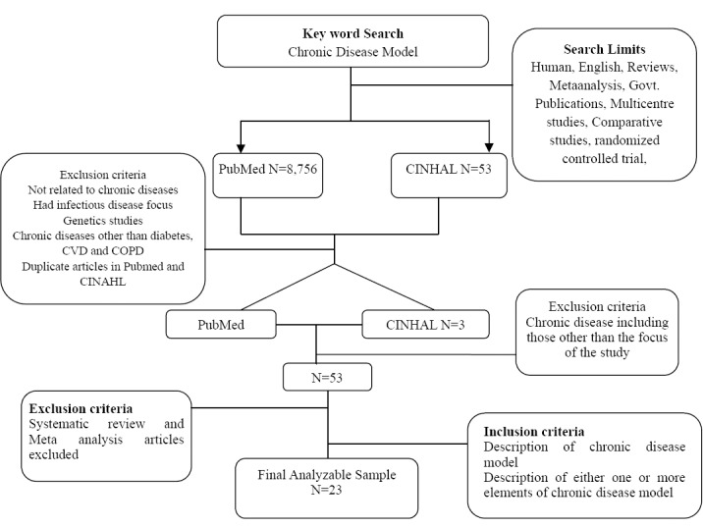

# [CHAPTE](https://1.bp.blogspot.com/-dODuK8N5h1Q/Wlnyb3V9HFI/AAAAAAAACL4/WxQtCJ1pM5wccDABg4wIrTBUB0vlikXQQCLcBGAs/s1600/poly1.jpg)R 7 IMPLEMENTATION

Implementation is the stage where the theoretical design is turned into a working system. The most crucial stage in achieving a new successful system and in giving confidence on the new system for the users that it will work efficiently and effectively.

The system can be implemented only after thorough testing is done and if it is found to work according to the specification. It involves careful planning, investigation of the current system and its constraints on implementation, design of methods to achieve the changeover, and an evaluation of change-over methods apart from planning.

Two major tasks of preparing the implementation are education and training of the users and testing of the system. The more complex the system being implemented, the more involved will be the system analysis and design effort required just for implementation.

The implementation phase comprises of several activities. The required hardware and software acquisition is carried out. The system may require some software to be developed. For this, programs are written and tested. The user then changes over to his new fully tested system and the old system is discontinued.

## TESTING

The testing phase is an important part of software development. It is the Information zed system will help in automate process of finding errors and missing operations and also a complete verification to determine whether the objectives are met and the user requirements are satisfied. Software testing is carried out in three steps:

1. The first includes unit testing, where in each module is tested to provide its correctness, validity and also determine any missing operations and to verify whether the objectives have been met. Errors are noted down and corrected immediately.
2. Unit testing is the important and major part of the project. So errors are rectified easily in particular module and program clarity is increased. In this project entire system is divided into several modules and is developed individually. So unit testing is conducted to individual modules.
3. The second step includes Integration testing. It need not be the case, the software whose modules when run individually and showing perfect results, will also show perfect results when run as a whole.

# [CHAPTE](https://1.bp.blogspot.com/-dODuK8N5h1Q/Wlnyb3V9HFI/AAAAAAAACL4/WxQtCJ1pM5wccDABg4wIrTBUB0vlikXQQCLcBGAs/s1600/poly1.jpg)R 8 SNAPSHOTS

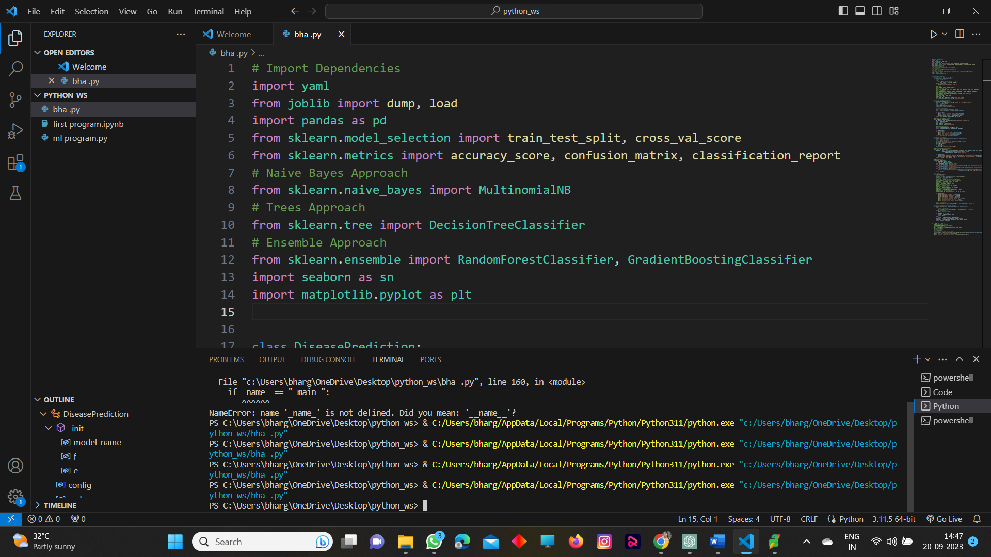

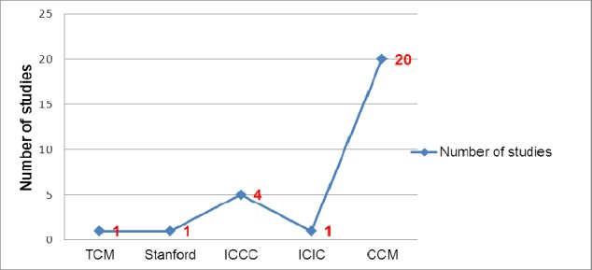

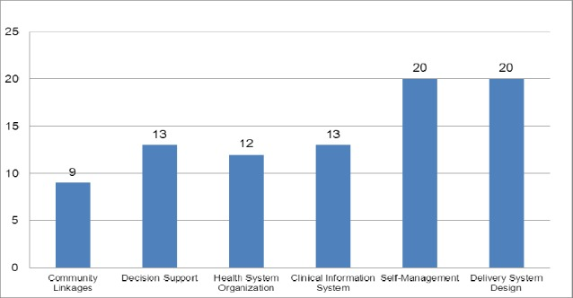

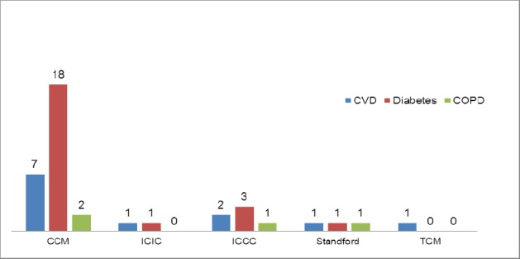

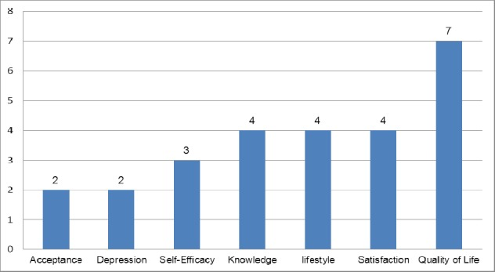

# [CHAPTE](https://1.bp.blogspot.com/-dODuK8N5h1Q/Wlnyb3V9HFI/AAAAAAAACL4/WxQtCJ1pM5wccDABg4wIrTBUB0vlikXQQCLcBGAs/s1600/poly1.jpg)R 9 CONCLUTION

The package was designed in such a way that future modifications can be done easily. The following conclusions can be deduced from the development of the project:

* Automation of the entire system improves the efficiency
* It provides a friendly graphical user interface which proves to be better when compared to the existing system.
* It gives appropriate access to the authorized users depending on their permissions.
* It effectively overcomes the delay in communications.
* Updating of information becomes so easier
* System security, data security and reliability are the striking features.
* The System has adequate scope for modification in future if it is necessary.

# REFERENCE

# https://ijarcce.com/

# https://www.nrigroupindia.com/